What makes the Relax Sauna different?

The Relax Sauna uses patented far infrared generators not found in any other sauna.

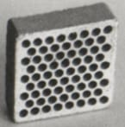
The ceramic chip used by the Relax Sauna.
Above is a patented ceramic chip that only the Relax far infrared sauna has. This chip is "tuned" to emit a certain frequency of far infrared in the 4.4 to 14.4 micron range. This is the perfect range of infrared for the body to absorb. Because of these chips(the Relax sauna contains 40 of them) the sauna emits both the highest and cleanest levels of infrared compared to any other sauna.

The generators are also very powerful at 750 watts each for a total of 1500 watts of far infrared energy. The makes the sauna heat up very fast, 30 seconds.
So you can get a full sweat in half the time it takes most saunas.

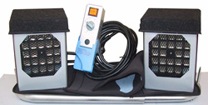Figure 1: Relax Sauna's patented far infrared generators

These far infrared generators are also safe. They are temperature controlled by micro-controllers which regulate the amount of power and thus the amount of infrared ray. A tissue paper held directly next the front of the radiators will not catch fire.
Read more about the Relax Far Infrared Sauna's technology here.

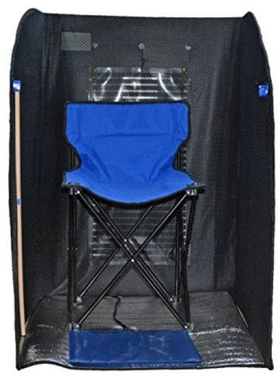

What far infrared generators do other saunas use?

Most Infrared Saunas Use Carbon Panels

These carbon panels contain carbon impregnated fabric that is electronically heated up. It emits a very mild amount of far infrared. Some saunas use more than one carbon panel. The problem with these are three fold.
1. Your upper body may be exposed to electrical magnetic frequencies (EMF) because these panels have many wires throughout them.
2. These cloth panels emit mild amounts of far infrared compared to the two 750 watt generators of the Relax Sauna.
3. Carbon panels do not induce fast profuse sweating like the Relax Sauna technology.

Quote from the book “Gastra Girl”
by Rebecca J Harder,Director of Colon Care in Portland Oregon
"Now I know the Relax infrared sauna does not look impressive, making it hard to believe that the best is not necessarily the most expensive and nicest looking one. Especially when you compare the Relax Sauna to the beautiful wooden saunas ... that have built-in stereos, lighting and that spa-like feeling. I understand your gut reaction.
For the last 10 years I have turned my nose up at the Relax Sauna every time I saw them at the health conferences until this last year when I tried one. I was sold on the Relax Sauna within the first 3 minutes! Right away I could feel the difference. No preheating like with the wooden saunas. In the Relax Sauna, I experienced instant relaxation from the higher quality infrared."

More testimonials comparing saunas:
"I used to go to a spa to use a big wooden sauna and I never got results like these! Even though the Relax Sauna costs far less, it does much more! Many thanks"
- Diana K(Submitted via email)
"In other saunas, like wooden ones, I have to sit 30+ minutes to work up a decent sweat, leaving me feeling sick and weak and my heart rate gets a little too rapid. This one squeezes every drop of sweat out of me before I have the chance to get to that point! I can only do about 15-20 minutes because it is so effective and powerful." -Breanna W
"The Relax Far Infrared Sauna that I purchased at the show is awesome. I have been looking for the best sauna for awhile now. It is the "real deal" and as far as I know this unit is the only one with medical device technology in the states. I especially love the flexibility of the sauna. The most important feature is that this particular sauna has a patented semi-conductor chip (which is the differentiating factor) which allows the absorbable FIR energy - the good 4-14 microns at temps up to 140-170 degrees - good for the body and with no harmful near and medium infrared rays. Other far infrared devices do not have this semi-conductor chip and hence do not generate far infrared light at high temps.
The amazing thing is that even though one sits in high temperatures, it is extremely comfortable. It is uniquely compatible with our energy and easily absorbed by the human body. You can actually feel its healing properties while sitting in the sauna. I have learned so much since using this sauna. I plan on purchasing another unit soon for a second location I am opening." / M.A. / Colorado

